
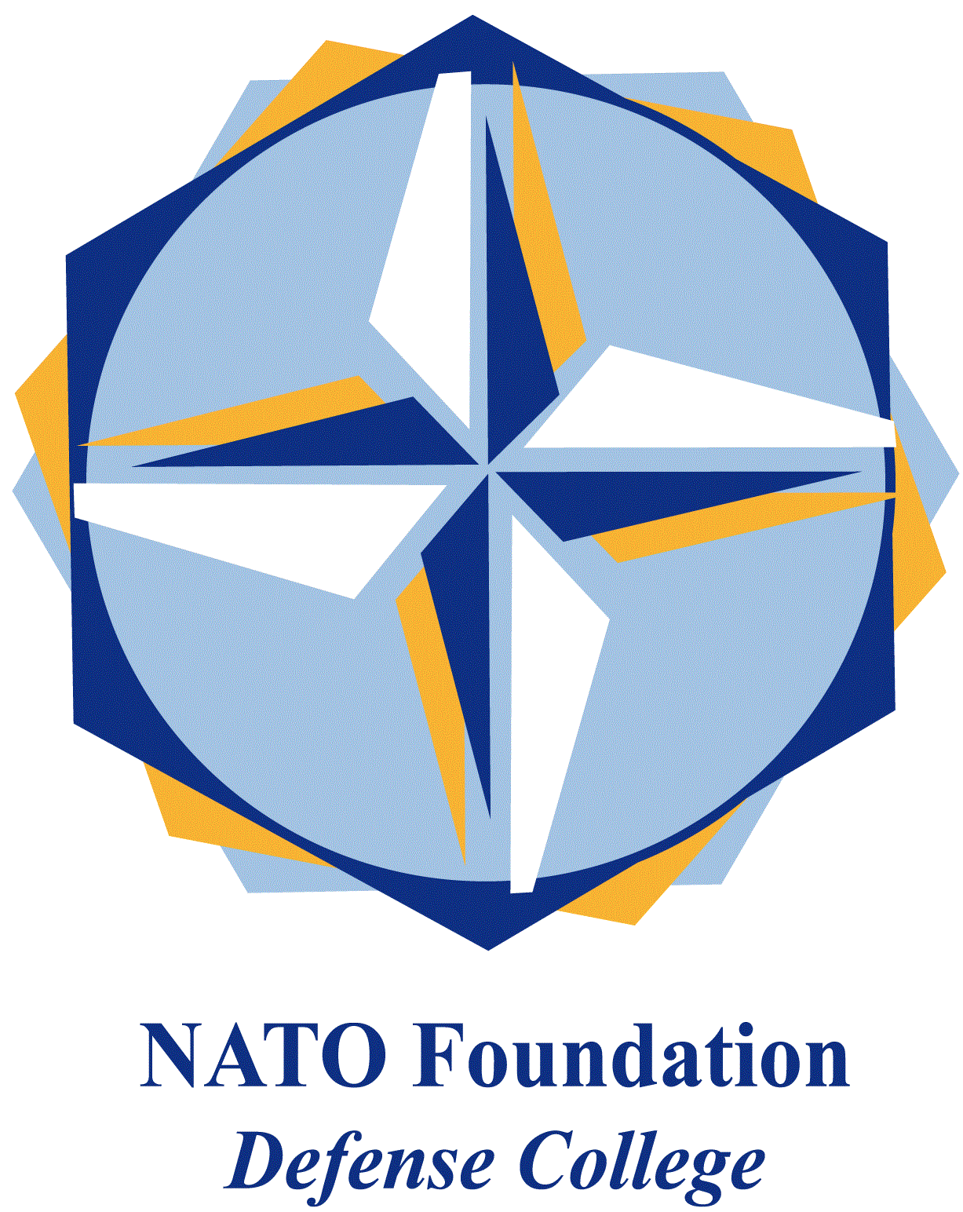
NATO DEFENSE COLLEGE FOUNDATION
STRATEGIC TRENDS
July 2015
EMERGING CHALLENGES
The Suruç attack and its consequences
The bomb attack on 20th July inside the Amara cultural centre in Suruç, a Turkish town only 30 kilometres from Kobane (the Kurdish enclave in Syria), seems to have triggered something more complex with an uncertain outcome than just a mere reaction to the threat of the Islamic State. The suicide bomber, who blew himself up in the garden of the Amara cultural centre where a rally of approximately 300 militants Socialist Youth Associations Federation (SGDF) was being held, seems to be connected – this is the version of the Turkish authorities – to a Turkish cell of the Islamic State and to be connected in some way to the boy held responsible for the explosion which took place on the eve of the elections of 7th June in Diyarbakir.
The toll of the attack, the toughest and bloodiest for at least the last two years and the first connected to the Islamic State on Turkish soil, is of 32 dead and 104 injured. The choice of the objective of the attack is significant; a rally of young Kurds from Suruç who were organising a collection of humanitarian aid in order to go and help to rebuild Kobane, the town which is considered the symbol of Kurdish resistance to the Islamic State. Despite the unanimous and immediate condemnation by President Recep Tayyip Erdogan – who condemned the attack regardless of its origin – and the Prime Minister Ahmet Davutoglu – who expressed the hope for cohesion among political parties in the entire nation – from the early hours harsh positions were taken the PKK which declared that it did not distinguish between the Turkish Intelligence Service and ISIS and defined the bombing as an attack against the Kurds by AKP.
Nevertheless, from the first hours following the attack, the theory that the suicide bombing in Suruç was the reply of the Islamic State to the change in Turkey’s policy towards the latter on the Syrian border has taken hold. Many people accuse the Turkish government of not having done enough over recent years to quash the threat of ISIS, considering the regime of Assad the true regional antagonist, and Turkey’s decision not to take part in raids carried out by the anti-ISIS coalition in Syria and Iraq has helped to increase these suspicions.
After several terrorist killings and widespread protests, Turkey found itself up against the threat of ISIS on its own territory, the resumption of tensions with the Kurdish population and in general the re-emerging of the Kurdish problem. In fact it is evident that the military successes which the Kurds are achieving in Syria after the resistance of Kobane and the conquest of Tal Abyad, are creating the conditions for the consolidation of the Kurdish presence in Northern Syria, in Rojava (better known as Syrian Kurdistan), an anticipator of an autonomous state.
Facing up to ISIS, reducing Kurdish expectations in Rojava and dealing a blow to Assad, these are the conflicting goals that would explain Ankara’s repeated requests to create a safety zone along the border in order to admit refugees and to impose a no-fly zone, an area where Assad’s troops and the extremist militia cannot intervene or control the territory. If, as Erdogan has declared, military action will last for several months, considering the stalemate situation of Turkish politics, it is difficult to imagine a strategic priority in what today appears to be a war on three fronts, difficult to sustain contemporarily.
The extraordinary NATO summit has confirmed some major allies’ support of the no-fly zone and for a buffer area, but several members insisted that the operation should receive UN’s approval and that negotiations with the PKK should be resumed.
It is likely that the recent agreement reached in Vienna on 14th July between Iran and the P5+1 together with the Kurdish advance into Northern Syria have in fact forced Ankara to take the plunge and pander to requests of the USA regarding their presence in the coalition against the Islamic State and, together with the Saudis and Jordan, consolidate a common Sunnite front against the influence of Shiite Iran in the area.

